**GENERAL INTEGRATED SCIENCE**

**TASK 7 – Test :**

**CYCLES, ecosystems and sustainability**

**NAME: _________________________________________________**

**WEIGHTING: 5 % Total Marks: / 40**

**Multiple Choice Questions** (7 marks)

1. Which of the following is NOT an abiotic factor?
2. Decomposer
3. Wind
4. Humidity
5. Temperature
6. Identify the possible link “A” in the following food chain: Plant 🡪Insect 🡪 Frog 🡪 A🡪 Eagle
7. Cobra
8. Parrot
9. Rabbit
10. Wolf
11. In earth’s ecosystems, energy:
12. is recycled and is never really lost.
13. flows from producers to consumers and back to producers.
14. flow in one direction, from producers to consumers.
15. is produced at all trophic levels of food chain.
16. When water droplets are large enough, to fall from the clouds, it is called
17. condensation
18. transpiration
19. sublimation
20. precipitation
21. In the carbon cycle, both terrestrial and aquatic organisms exchange _________ with the atmosphere.
22. Sugar
23. Oxygen gas
24. Carbon dioxide
25. Methane
26. A consequence of cutting down of forests is
27. that water is no longer returned to the atmosphere over the area of the forest.
28. the loss of animal habitat.
29. the production of high quality agricultural land.
30. all of the above.
31. How are the greenhouse gases believed to be causing the temperature of earth to increase?
32. They allow more solar radiation to pass through to the earth’s surface.
33. They prevent the heat energy from leaving the earth.
34. By absorbing sunlight .
35. By reducing photosynthetic rates .

**Short Answer Questions**

1. The three main spheres that make up our earth are Lithosphere, Atmosphere and Hydrosphere. Write a description of each of the spheres in the space below. (3 marks)

Lithosphere: ____________________________________________________________________________

____________________________________________________________________________

Atmosphere: ____________________________________________________________________________

____________________________________________________________________________

Hydrosphere: ____________________________________________________________________________

____________________________________________________________________________

1. Explain why the atmosphere is very important to maintaining life on Earth? (1 marks)

___________________________________________________________________________________________________________________________________________________________________________________________________________________________________________________________________________

1. On Earth there are many factors that life depends upon. These are referred to as **Abiotic** and **Biotic** factors. In the space below write a description of each of these factors. (2 marks)

Abiotic: ____________________________________________________________________________

____________________________________________________________________________

Biotic: ____________________________________________________________________________

____________________________________________________________________________

1. The Emu is a native animal to Australia. There are several factors that affect the Emu during its life. List **one** abiotic and **one** biotic factor that would affect the Emu and give an **explanation** of how they affect the Emu.

(4 marks)

Abiotic factor: ___________________

Explanation: ____________________________________________________________________________

____________________________________________________________________________

____________________________________________________________________________

____________________________________________________________________________

Biotic factor: ___________________

Explanation: ____________________________________________________________________________

____________________________________________________________________________

____________________________________________________________________________

____________________________________________________________________________

1. Describe what a food chain is? (1 marks)

__________________________________________________________________________________________________________________________________________________________________________________

Below is a diagram of the food web of a marine ecosystem.

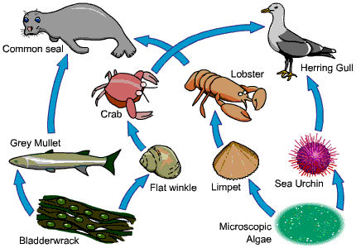

1. Draw a food chain from this food web. (1 mark)

________________ 🡪 ________________ 🡪 _________________ 🡪 __________________

1. Using the food web, write the name of a: (3 marks)
2. Carnivore __________________________
3. Herbivore __________________________
4. Producer __________________________
5. Primary Consumer __________________________
6. Secondary Consumer __________________________
7. Tertiary Consumer __________________________
8. What do the arrows in a food chain represent? (1 mark)

__________________________________________________________________________________ __________________________________________________________________________________

__________________________________________________________________________________

1. A disease has wiped out most of the flat winkle population. Giving an explanation, what will happen to the numbers of: (3 marks)
2. Grey Mullet _____________________________________________________________________

_______________________________________________________________________________

1. Crab ___________________________________________________________________________

________________________________________________________________________________

1. Lobster _________________________________________________________________________

_______________________________________________________________________________

1. The water cycle describes how water moves from one place to another and changes form from liquid to vapour. Label the six processes that occur in the water cycle on the diagram below. (6 marks)

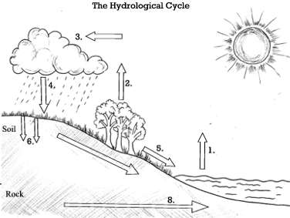

1. Explain how trees move water from one storage place to another as part of the water cycle. (1 mark)

_____________________________________________________________________________________________________________________________________________________________________________________________________________________________________________________________________

1. Climate change can have a drastic effect on the water cycle. Describe one way that climate change can affect the water cycle. Include how plants and animals would be affected by this change. (3 marks)

__________________________________________________________________________________________________________________________________________________________________________________________________________________________________________________________________________________________________________________________________________________________________________________________________________________________________________________________________________________________________________________________________________

1. 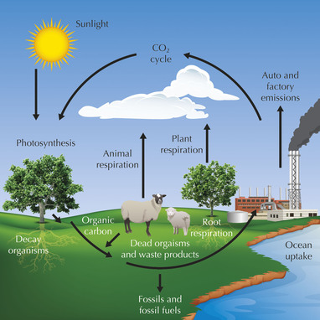

Carbon is a major part of all living things. Explain how carbon gets into living things and how it is then returned to the atmosphere. (4 marks)

____________________________________________________________________________________________________________________________________________________________________________________________________________________________________________________________________________________________________________________________________________________________________

____________________________________________________________________________________________________________________________________________________________________________________________________________________________________________________________________________________________________________________________________________________________________

_______________________________________________________________________________________________________________________________________________________________________________________________________________________________________________________________________________________________________________________________________________________________________________________________________________________________________________________________________________________________________________________________________________________________________________________________________________________________________________